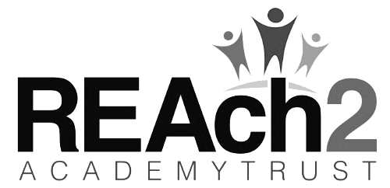


30 Hours Nursery Agreement

1. Child's details

Child's Legal Family Name: |  | Child's Legal Forename(s):
Name by which the child is known (if different from above):

Date of Birth: |  | Male/Female:
Address: |  | Post Code:
Parents Legal Names: |  | National Insurance Number:
Date of Birth: |  | 30 Hours Eligibility DERN Code:
Email Address:

2. Option required – please highlight or tick

Option 1 | Option 2
Monday to Friday 8.45am – 3.30pm  Children will need a packed lunch to take to lunch club.  For this option there is a £5 charge for lunch club per day. This will need to be paid termly. You will receive an invoice for this. | Monday to Thursday 8.45am – 3.30pm and Friday 8.45am – 11.45am  Children will need to bring a pack lunch to take to lunch club.  There is no charge for this option.

Terms and Conditions, Please read and sign to confirm that you accept:
- That the fee is still payable in the event of my child being sick or absent for any reason and that it is not refundable.
- Fees are payable half termly in advance.
- Fees are payable in full from the day your child starts (There is no free settling in period)
- Fees must be paid within 2 weeks, or the school has the right to withdraw the Service.
- It is very important to arrive and collect on time as late collection is very unsettling for your child and may incur a change.
- If you wish to discontinue the use of our Nursery, you must write to us, giving a minimum of 4 weeks’ notice and you will be charged for these 4 weeks.
- The School will provide the highest quality care and education.
- I understand that failure to keep to this agreement may result in the loss of the place

I have read and agreed to the stated terms and conditions.

Signed: ______________________________________________ (parent/carer)

Print Name: ______________________________________________

Date:________________________________


